Disorders of Platelet Function

Table of Contents
Basics 3
Platelet Structure 3
Quiescence 3
Adhesion 3
Platelet activation 3
Thrombin 3
Other Mechanisms 3
Aggregation 3
First Wave of Aggregation 3
Second Wave of Aggregation 3
Inherited Disorders of Platelet Function 5
Defects in platelet-vessel wall interaction (disorders of adhesion) 5
von Willebrand disease (deficiency or defect in plasma vWF) 5
Bernard-Soulier syndrome (deficiency or defect in GPIb/IX/V) 5
Defects in Platelet-Platelet Interaction (disorders of aggregation) 6
Congenital afibrinogenemia (deficiency of plasma fibrinogen) 6
Glanzmann thrombasthenia (deficiency or defect in GPIIb-IIIa) 6
Disorders of Platelet Secretion and abnormalities of granules 6
Storage pool deficiency (dααd) 6
Quebec platelet disorder 6
Hermansky-Pudlak Syndrome 6
Gray Platelet Disorder 6
Disorders of platelet secretion and signal transduction 6
Disorders of platelet coagulant-protein interaction (Scott syndrome) 6
Defects related to cytoskeletal/structural proteins 6
Abnormalities of transcription factors leading to functional defects 6
Acquired Disorders of Platelet Function 6
Medications 6
SSRIs 6
Acetyl-Salicylic Acid 6
P2Y12 Antagonists 7
GIIbIIA Antagonists 7
Dipyridamole 7
Cilostazol 7
Thrombin Inhibitors 7
Resistance to Anti-Platelet Therapy 7
Aspirin Resistance 7
Overview 7
Basics of Aspirin 7
Basics of Aspirin Resistance 7
Potential Assays for Detection 7
Potential Causes of Pseudo-Resistance 7
Drug-Drug Interactions 7
Conditions of Increased Platelet Turnover 8
Clopidogrel Resistance 8
Basics of Clopidogrel 8
Potential Assays for Detection 8
Evaluation 9

Basics

Platelet Structure
- The platelet diameter ranges from 1.5 to 3.0 μm, roughly one-third to one-fourth that of erythrocytes
- Platelet volume is approximately 7 fL

Quiescence
- Platelets normally circulate in a resting discoid form maintained via inhibition of platelet activation by:
  - Endothelial-derived Nitric Oxide
  - Endothelial-derived Prostaglandin I₂ (prostacyclin)
  - Scavenging of adenosine diphosphate (ADP) by endothelial surface CD39

Adhesion
- Initial platelet adhesion to damage vessel walls is mediated by exposed collagen
  - Glycoprotein VI binds collagen and starts the platelet activation process
  - Collagen also binds integrin alpha2beta1
- VWF also aids in adhesion by binding to the GPIb-X-V on the platelet surface

Platelet activation
- Flipping of phosphatidyl serine from inner membrane to outer membrane which is important for the coagulation

Thrombin
- Thrombin, generated by the coagulation cascade, is a potent activator of human platelets
  - Binds to specific membrane receptors:
    - Protease-activated receptor (PAR)1 and PAR 4

Other Mechanisms
- Three groups of platelet surface receptors provide important positive feedback loops for platelet activation
  - P2Y12 receptors
  - 5-HT2 receptors
  - Thromboxane prostanoid receptor
    - TxA2 is generated by the platelet COX 1-dependent signaling pathway

Aggregation
- Triggered by Adhesion and mediated by fibrinogen and, at high shear flow, VWF binding to the activated confirmation of integrin alpha IIb beta 3 (GPIIbIIIa)
- Alpha granules and dense granules
  - Dense
    - Serotonin and ADP
  - TxA2 (Thromboxane A2)
    - Vasoconstriction
  - Alpha
    - Big proteins you can’t pack into dense granules
    - Platelet factor IV
- Key aggregation step is the extension of IIbIIIa to grab fibrinogen

First Wave of Aggregation
- Relies on thrombin, collagen, epi, serotonin, ADP, TxA2

Second Wave of Aggregation
- Relies on the release of dense granules
  - Either deficient
  - Or problem with secretion
    - Hermansky Pudlack
    - Chediak Higashi
  - Need to do EM to look for the granules

Inherited Disorders of Platelet Function

Defects in platelet-vessel wall interaction (disorders of adhesion)

von Willebrand disease (deficiency or defect in plasma vWF)

Bernard-Soulier syndrome (deficiency or defect in GPIb/IX/V)
- Bernard-Soulier syndrome (BSS) is an autosomal recessive familial thrombocytopenic disorder characterized by the absence of the platelet GPIb-IX-V complex that is associated with large platelets, lack of platelet aggregation by high- dose ristocetin, and bleeding
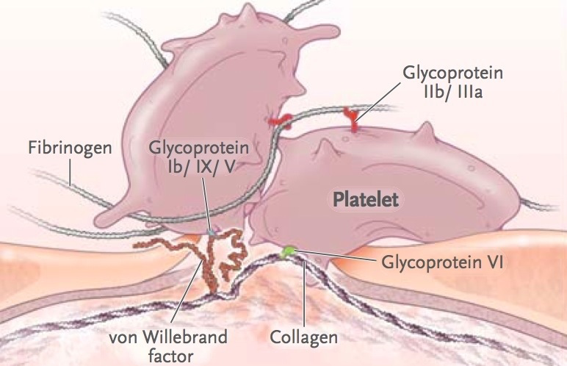

Defects in Platelet-Platelet Interaction (disorders of aggregation)

Congenital afibrinogenemia (deficiency of plasma fibrinogen)

Glanzmann thrombasthenia (deficiency or defect in GPIIb-IIIa)

Disorders of Platelet Secretion and abnormalities of granules

Storage pool deficiency (dααd)

Quebec platelet disorder

Hermansky-Pudlak Syndrome
- Dense granule storage pool deficiency (δ –SPD)
- Oculocutaneous albinism and nystagmus
- Presence of primary wave and absence of the second wave of aggregation
- Also lack alpha granules

Gray Platelet Disorder
- No alpha granules
- Patients do not have marked abnormalities in platelet aggregation responses

Disorders of platelet secretion and signal transduction
  - Defects in platelet-agonist interaction (receptor defects) (ADP, Thromboxane A2, Collagen, Epinephrine)
  - Defects in G-proteins (Gαq, Gαs, Gαi Abnormalities)
  - Defects in phosphatidylinositol metabolism and protein phosphorylation
    - Phospholipase C-β2 Deficiency
    - PKC-q deficiency
  - Abnormalities in arachidonic acid pathways and thromboxane A2 synthesis
    - Phospholipase A2 deficiency
    - Cyclooxygenase deficiency
    - Thromboxane synthase deficiency

Disorders of platelet coagulant-protein interaction (Scott syndrome)

Defects related to cytoskeletal/structural proteins
- Wiskott-Aldrich syndrome
- β1-Tubulin deficiency

Abnormalities of transcription factors leading to functional defects
- RUNX1 (familial platelet dysfunction with predisposition to acute myelogenous leukemia)
- GATA1
- FLI-1 (Dimorphic dysmorphic platelets with giant α-granules
- and thrombocytopenia; Paris-Trousseau/Jacobsen syndrome)

Acquired Disorders of Platelet Function

Medications

SSRIs
- Inhibit the uptake of serotonin by platelets
  - Serotonin released by platelets at sites of vascular injury amplifies the platelet response and thrombus formation

Acetyl-Salicylic Acid
- ASA acetylates serine 529 on COX1 and thereby blocks TxA2 generation

P2Y12 Antagonists
- Prevent ADP-dependent amplification of stable platelet aggregation and secretion

GIIbIIA Antagonists
- Block the binding of fibrinogen, and at high shear, VWF, to GPIIbIIIa

Dipyridamole
- PDE inhibitor that has antiplatelet and vasodilatory properties

Cilostazol
- PDE inhibitor that has antiplatelet and vasodilatory properties

Thrombin Inhibitors
- UFH, LMWH, DTIs (lepirudin, argatroban, bivalirudin, dabigatran)
- These, by inhibiting thrombin can result in less platelet activation

Resistance to Anti-Platelet Therapy

Aspirin Resistance

Overview

Basics of Aspirin
- Low-Dose ASA is usually completely sufficient to inhibit platelet COX1
  - In fact 75 mg daily is at least twice as high as the lowest dose necessary and sufficient to fully inhibit platelet COX-1 activity
    - Therefore, there is no difference between 75 mg and 100 mg (the commercially available doses for “low-dose ASA”) (Patrono C. J Am Coll Cardiol. 2015;6(1):74-85
- Of note, therefore 325 mg ASA is only really beneficial as a loading dose

Basics of Aspirin Resistance
- “Aspirin Resistance” if defined as the failure of ASA intake to fully inactivate its target, platelet COX1, is either extraordinarily rare, or does not exist
  - In a study of 400 healthy volunteers, 0/400 failed to exhibit this phenomenon
- “Pseudo-Resistance” is another matter
  - This likely reflects delayed and reduced drug absorption, and therefore reduced pharmacodynamics
  - I.e there is likely no pharmacodynamics resistance, only pharmacokinetic resistance

Potential Assays for Detection
- Measurement of TxB₂, the stable metabolite of TxA₂
  - Can be measured in the serum or urine as 11-dehydro TxB₂
- Other assays exist, if needed look back to Michelson and Bhatt. Blood. 2017;130(6):713-721

Potential Causes of Pseudo-Resistance

Drug-Drug Interactions
- NSAIDs
  - NSAIDs such as ibuprofen - I’m not sure of the mechanism (need to look it up) – can inhibit the action of ASA and decrease it’s anti-platelet effect (Catella-Lawson F et al NEJM 2001;345(25):1809-1817; Capone ML et al J Am Coll Cardiol 2005;45(8):1295-1301; Li X et al Proc Natl Acad Sci USA. 2014; 111(47):16830-16835; Renda G et al. Clin Pharmacol Ther. 2006; 80(3):264-274.
    - Is it b/c ibuprofen is a non-permanent COX1 inhibitor and thus it it binds to and inhibits COX1, ASA cannot acetylate the enzyme and permanently inhibit it?
  - Thus, if you are going to use both, consider giving ASA 2 hours b/f an NSAID (Catella-Lawson F et al NEJM 2001;345(25):1809-1817)
    - That said, multiple doses of an NSAID can abrogate this beneficial effect

Conditions of Increased Platelet Turnover
- DM, Obesity, ET, other MPNs, and CABG can result in increased platelet turnover
- Thus, increasing the dose is less effective than increasing the frequency to BID
  - Of note, clinical benefit of this strategy has not been shown

Clopidogrel Resistance

Basics of Clopidogrel
- Esterases degrade ~85% of absorbed clopidogrel, leaving only ~15% to be converted by the cytochrome P-450 family of enzymes to the active metabolite required to inhibit P2Y₁₂
- Variability of pharmacokinetic and pharmacodynamics of clopidogrel result from numerous factors
  - Diet
  - Polymorphisms in the transporter molecule ABCB1
  - Smoking (which alters CYP450 levels)
  - CYP2C19 polymorphisms
  - DDIs
    - PPIs
  - Other
    - obesity, impaired renal dysfunction, DM, age, reduced LVF, inflammation

Potential Assays for Detection
- Stimulate platelets with ADP and drug and there are a number of readouts (see Michelson Blood 2017)
- Polymorphisms in CYP2C19 lead to decreased activation of clopidogrel and decreased efficacy

Evaluation

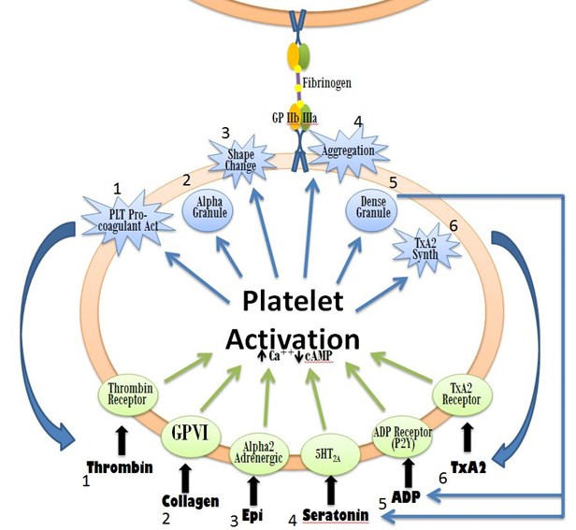

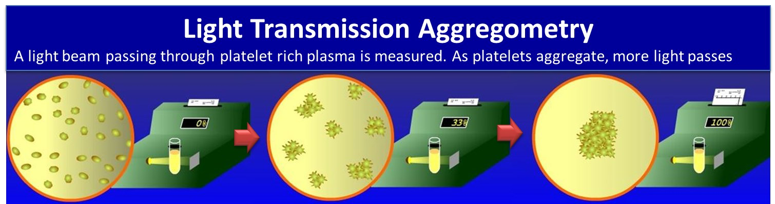

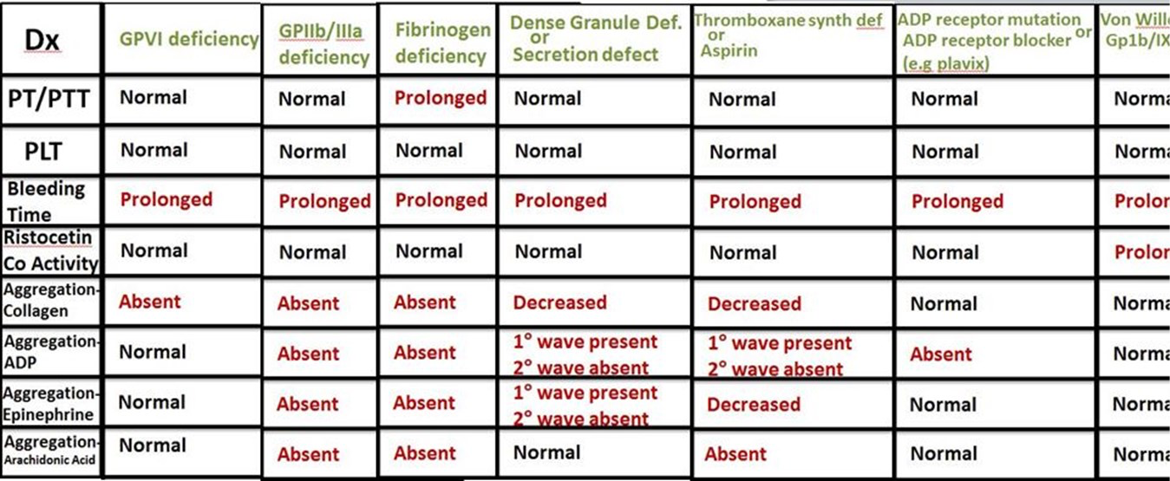

- Arachidonic Acid is converted to TxA2 if COX-1 and Thromboxane synthase are present causing a strong platelet activation.
- Ristocetin causes a conformation change in VWF which increases its affinity for GP1b/IX/V.
  - This causes a non-physiologic “agglutination” of platelets where they are connected by Gp1b and VWF rather than GPIIb/IIIa and fibrinogen (the predominant linker of platelets in vivo).
- AA gets converted into supra-physiologic amounts of TxA2 leading to strong platelet activation independent of the dense granule related 2nd wave.
- Dense Granule Deficiency AKA Storage Pool Disease can be an isolated syndrome or part of other genetic diseases such as Hermansky-Pudlak, Chediak-Higashi, or Wiskott-Aldrich
- Distinguish a deficiency in dense granules from a disorder of secreting dense granules by electron mi- croscopy to see whether dense granules are present
- Epinephrine causes a 2nd wave despite the absence of ADP signaling since other dense granule contents are still present (ATP and serotonin)
- Thrombogenomics
  - Capture array
    - Hybrid capture with oligonucleotides
  - Next Gen Seq assay looking at the known 49 genes responsible for platelet defects
  - Mendelian disorders
    - You don’t need deep coverage like you do in tumor where you need multiple coverage (modern assays are 1000x)

